
Palestine Technical College
Department of Computer Systems Engineering
Object-Oriented Programming (OOP)

PROJECT REPORT
Gaza Humanitarian Aid Distribution System
(GHADS)

Prepared by:
Noura Mahmoud Srour — ID: 2549011082
Afnan Mohamed Zaqout — ID: 2549011044
Huda Abdullah Abu Tailkh — ID: 2549011077
Shahd Hassan Abu Al-Aish — ID: 2549011055

Submitted to:
Dr. Suheir Harb

July 16, 2026

Table of Contents
Table of Contents 2
1. Project Description 4
2. Main Features 4
2.1 User Roles 4
2.2 Managing Distribution Records 4
2.3 Family Eligibility Check 4
2.4 Priority-Based Sorting 5
2.5 File Handling & Persistence 5
2.6 Password Verification 5
2.7 Live Inventory Dashboard 5
2.8 JavaFX Graphical User Interface 5
3. OOP Concepts Used 6
3.1 Encapsulation 6
3.2 Inheritance 6
3.3 Abstraction 7
3.4 Polymorphism 7
3.5 Interface — Comparable<T> 7
3.6 Composition & Aggregation 8
3.7 Static Members & Utility Design 8
4. Main Classes 9
4.1 User 9
4.2 Organization 9
4.3 Volunteer 9
4.4 Family 9
4.5 AidDistribution 9
4.6 DatabaseManager 9
4.7 GHADSApp 9
4.8 Class Summary 10
5. UML Class Diagram 11
Relationship Explanation 11
6. Screenshots 13
Figure 2 — Main Dashboard 13
Figure 3 — Organization Login 13
Figure 4 — Successful Login 14
Figure 5 — Add Distribution 15
Figure 6 — Edit Distribution 15
Figure 7 — Delete Distribution 15
Figure 8 — Project Structure & Inheritance in NetBeans 17
7. Challenges 18
8. GitHub Repository Link 18
9. Video Presentation Link 18
10. AI Usage Declaration 18

Note: right-click the table above and choose "Update Field" (or press F9) after opening this document in Microsoft Word to populate the page numbers.

1. Project Description
GHADS (Gaza Humanitarian Aid Distribution System) is a JavaFX desktop application developed to manage the distribution of humanitarian aid to beneficiary families in Gaza. The system stores information about registered families and records every aid-distribution operation in an organized, centralized, and auditable way.
The system supports two user roles — Organization and Volunteer — each with different permissions. An organization account can add, edit, and delete distribution records, while a volunteer account is restricted to viewing existing records and adding new ones. This role separation is enforced through a password-protected login gate, so that only an authenticated organization user can perform sensitive edit or delete operations.
When a new distribution is added, the system automatically checks whether the receiving family is eligible for aid based on the date it last received assistance: a family is eligible if it has never received aid before, or if at least 30 days have passed since its last recorded distribution. The system also supports priority-based sorting of distribution records — displaced families are given higher priority, and when two families share the same displacement status, the family with more members is ranked first.
To ensure that data is never lost between sessions, every distribution record is saved to a UTF-8 text file through a dedicated persistence class. When the application starts again, previously saved records are loaded automatically, so field teams can pick up exactly where they left off — an important property given the often unstable power and connectivity conditions the system is designed to operate under.
This project was developed as part of the Object-Oriented Programming course to apply the main OOP concepts — encapsulation, inheritance, abstraction, polymorphism, interfaces, and composition — in a realistic, socially meaningful Java application.

2. Main Features

2.1 User Roles
The system supports two user roles: Organization and Volunteer. Each role has different permissions. The organization can add, edit, and delete distribution records, while the volunteer can only add new records and view existing ones.

2.2 Managing Distribution Records
The system allows users to add, edit, delete, and view aid-distribution records through a JavaFX graphical user interface. Each record contains information about the family, the organization, and the distributed aid.

2.3 Family Eligibility Check
Before a new distribution is recorded, the system checks whether the selected family is eligible to receive aid. The decision is based on the family's last aid date, which prevents repeated distributions to the same family within a short period.

2.4 Priority-Based Sorting
The system can sort distribution records according to priority. Displaced families are given higher priority; if two families share the same displacement status, the family with more members is given higher priority. This entire ordering rule is implemented in a single reusable method, described further in Section 3.5.

2.5 File Handling & Persistence
All distribution records are saved to a text file in UTF-8 encoding. When the application starts again, the saved data is loaded automatically, so users do not lose their records after closing the program. While loading, the system checks each stored row and safely skips invalid or incomplete records instead of crashing.

2.6 Password Verification
Some operations require authentication. Before accessing organization-level functions, the user must enter the correct password. Passwords are never stored or compared in plain text — they are hashed with SHA-256 the moment they are set, and only the hash is ever stored or checked. This protects important operations from unauthorized access.

2.7 Live Inventory Dashboard
A statistics panel on the main dashboard recalculates, in real time, the total number of registered families, the opening warehouse stock, the total units already distributed, and the remaining safe reserve — giving staff an at-a-glance view of resource availability.

2.8 JavaFX Graphical User Interface
The project uses JavaFX to provide a user-friendly, fully right-to-left Arabic interface. Users can perform all operations using buttons, forms, dialog boxes, and tables, without needing to use a console.

3. OOP Concepts Used
The project was deliberately structured to demonstrate the main pillars of object-oriented design across a small but realistic domain model.

3.1 Encapsulation
Encapsulation was used by declaring class attributes as private and accessing them only through getter and setter methods. This protects the internal state of an object and allows controlled access when needed. Almost all classes in the project — User, Family, and AidDistribution among them — follow this approach.
private int user_ID;
private String user_Name;
private String password;
private String user_Type;

public int getUser_ID() {
return user_ID;
}
public void setUser_ID(int user_ID) {
this.user_ID = user_ID;
}
This example shows that the attributes are hidden using the private modifier, while the getter and setter methods provide controlled access to them. The User class goes a step further: setPassword(...) is declared final and always routes the raw input through a private hashPassword(...) method, so a hashed password can never accidentally be bypassed, even by a subclass.

3.2 Inheritance
Inheritance was used to avoid code duplication and to share common data and methods between different user types. The abstract class User is the parent class, while Organization and Volunteer inherit from it. Both subclasses reuse the common user information (ID, name, hashed password, type) and provide their own additional field and role permissions.
public abstract class User {
...
}

public class Organization extends User {
private String coverage_Area;
...
}

public class Volunteer extends User {
private String assigned_Area;
...
}
This allows both Organization and Volunteer to reuse the attributes and methods defined in User instead of re-implementing authentication and identity logic in every class.

3.3 Abstraction
Abstraction was implemented using the abstract class User. The method getRolePermissions() was declared as an abstract method, meaning every subclass must provide its own implementation according to its role in the system.
public abstract String getRolePermissions();

// Organization
@Override
public String getRolePermissions() {
return "Permissions: Add Aid Items, Update Inventory, and "
+ "Distribute Resources in " + coverage_Area;
}

// Volunteer
@Override
public String getRolePermissions() {
return "Permissions: View records and Add new distributions in "
+ assigned_Area + " (Edit and Delete are restricted).";
}
This design allows each user type to define its own permissions while keeping one common method declaration in the parent class.

3.4 Polymorphism
Polymorphism was implemented in the GHADSApp class through the accountForRole() method. The method returns a reference of type User, but the actual object can be either an Organization or a Volunteer, depending on the role currently selected in the interface.
private User accountForRole(String role) {
return (role != null && role.startsWith("Org"))
? unicef
: fieldVolunteer;
}

// usage
permissionsLabel.setText(
accountForRole(currentRole).getRolePermissions();
Although the reference type is User, Java calls the correct implementation of getRolePermissions() depending on whether the actual object is an Organization or a Volunteer. This is runtime polymorphism, and the same pattern is reused for the toString() overrides across User, Organization, Volunteer, Family, and AidDistribution.

3.5 Interface — Comparable<T>
The AidDistribution class implements the Comparable<AidDistribution> interface. It overrides the compareTo() method to encode the project's priority rules directly inside the domain object, so the interface gives higher priority to displaced families, and if both families share the same displacement status, to the family with the larger number of members.
public class AidDistribution implements Comparable<AidDistribution> {
@Override
public int compareTo(AidDistribution other) {
if (this.receiving_Family.isIs_Displaced()
&& !other.receiving_Family.isIs_Displaced()) {
return -1;
}
if (!this.receiving_Family.isIs_Displaced()
&& other.receiving_Family.isIs_Displaced()) {
return 1;
}
return Integer.compare(
other.receiving_Family.getMember_Count(),
this.receiving_Family.getMember_Count());
}
}
This lets the interface do all the work of the sorting policy: the user interface simply calls Collections.sort(distributionList) and the entire priority rule described in Section 2.4 is applied in one line.

3.6 Composition & Aggregation
GHADSApp owns an ArrayList<AidDistribution> as a whole-part composition: the list's lifecycle is entirely managed by the application, rebuilt from disk on startup, and written back to disk on every change. Each AidDistribution, in turn, aggregates references to one Organization and one Family object — it depends on those objects to exist but does not own their lifecycle, since the same Family or Organization could conceptually be referenced by more than one record.

3.7 Static Members & Utility Design
DatabaseManager exposes only static saveToFile(...) and loadFromFile(...) methods, since file persistence does not need any per-instance state and is naturally a utility class. Similarly, Family.normalizeLastAidDate(...) and the STATUS_DELIVERED / STATUS_WAITING constants in AidDistribution are static, providing shared, class-level rules rather than per-object data.

4. Main Classes

4.1 User >> (Noura Mahmoud Srour)
The User class is the abstract parent class for all users in the system. It stores the common information of every user, including the user ID, username, password, and user type. The password is stored as a hash instead of plain text, and the class provides a method to verify an entered password against that hash. The class also declares the abstract method getRolePermissions(), which must be implemented by every subclass according to its role in the system.

4.2 Organization >> (Afnan Mohamed Zaqout )
The Organization class extends the User class and represents the humanitarian organization responsible for distributing aid. In addition to the inherited user information, it stores the organization's coverage area. The class provides its own implementation of getRolePermissions(). In the application, the Organization role is allowed to add, edit, and delete distribution records after successful password verification.

4.3 Volunteer >> (Huda Abdullah Abu Tailkh )
The Volunteer class extends the User class and represents a volunteer working in the field. It stores the volunteer's assigned area and provides its own implementation of getRolePermissions(). In the application, the Volunteer role can view existing records and add new distribution records, but it cannot edit or delete existing ones.

4.4 Family>> (Huda Abdullah Abu Tailkh )
The Family class stores information about a beneficiary family: the family ID, family name, number of members, contact number, displacement status, and the date of the last aid received. This class also contains the isEligibleForAid() method, which checks whether the family is eligible to receive aid — a family is considered eligible if it has never received aid before, or if at least 30 days have passed since its last aid distribution.

4.5 AidDistribution >> (Afnan Mohamed Zaqout )
AidDistribution stores one aid-distribution record. It connects an Organization object with a Family object and stores the distribution ID, the distributed quantity, and the receipt status. When a new distribution record is created, the class checks the family's eligibility: if the family is eligible, the status becomes Delivered and the last aid date is updated; otherwise the status becomes On Waiting List. The class also implements the Comparable<AidDistribution> interface to support priority-based sorting, as described in Section 3.5.

4.6 DatabaseManager >> (Shahd Hassan Abu Al-Aish )
The DatabaseManager class is responsible for file handling. It saves all distribution records to a text file and loads them again when the application starts. While loading the file, the class checks the stored data and skips invalid or incomplete records to prevent the application from crashing.

4.7 GHADSApp
GHADSApp is the main JavaFX application. It builds the graphical user interface and connects all the other classes together. Through this class, users can log in, select a role, add, edit, delete, view, and sort distribution records. It also validates user input, checks passwords, updates the displayed statistics, calculates the available stock, and saves changes using the DatabaseManager class. The accountForRole() method returns a User reference that can represent either an Organization or a Volunteer — this method demonstrates the runtime polymorphism described in Section 3.4.

4.8 Class Summary
Class | Role in the System | Key Responsibilities
User (abstract) | Base identity & security contract for every account type. | Stores ID/name/role, hashes and verifies passwords, declares abstract getRolePermissions().
Organization | Represents an aid organization (e.g., UNICEF_Gaza). | Full CRUD permissions; tracks a coverage_Area; supplies its own permissions text.
Volunteer | Represents a field volunteer. | View + add-only permissions; tracks an assigned_Area.
Family | Represents a beneficiary household. | Holds contact & size data, displacement flag, last aid date; computes 30-day eligibility.
AidDistribution | Represents one distribution transaction linking an Organization to a Family. | Validates inputs, sets Delivered / Waiting status, implements priority ordering via Comparable.
DatabaseManager | Persistence layer. | Serializes/deserializes the distribution list to/from a UTF-8 text file, skipping corrupt rows safely.
GHADSApp | JavaFX application entry point / controller. | Builds the UI, wires button actions, enforces role-based UI state, and orchestrates all other classes.

5. UML Class Diagram
Relationship | Classes | Explanation
Inheritance | Organization → User | The Organization class inherits the common attributes and methods from the abstract User class.
Inheritance | Volunteer → User | The Volunteer class also inherits from User and provides its own implementation of getRolePermissions().
Interface | AidDistribution ⇢ Comparable<AidDistribution> | AidDistribution implements the Comparable interface to sort distribution records by priority.
Aggregation | AidDistribution ↔ Organization | Each aid-distribution record is linked to one organization that manages the distribution.
Aggregation | AidDistribution ↔ Family | Each aid-distribution record is linked to one beneficiary family.
Composition | GHADSApp ● AidDistribution | GHADSApp owns and manages the full lifecycle of the in-memory list of distribution records.
Dependency | GHADSApp → DatabaseManager | GHADSApp uses DatabaseManager to save and load distribution records.
Dependency | DatabaseManager → AidDistribution | DatabaseManager reads and writes AidDistribution (and nested Family) data to the storage file.
Abstract Class | User | User is an abstract class that provides common data and methods for all user types.
The following UML class diagram shows the structure of the GHADS system. It includes the main classes, their attributes, methods, and the relationships between them: the inheritance relationship between User and its subclasses (Organization and Volunteer), the aggregation and association relationships between the main classes, the abstract class User, and the implementation of the Comparable interface by the AidDistribution class.

Relationship Explanation:

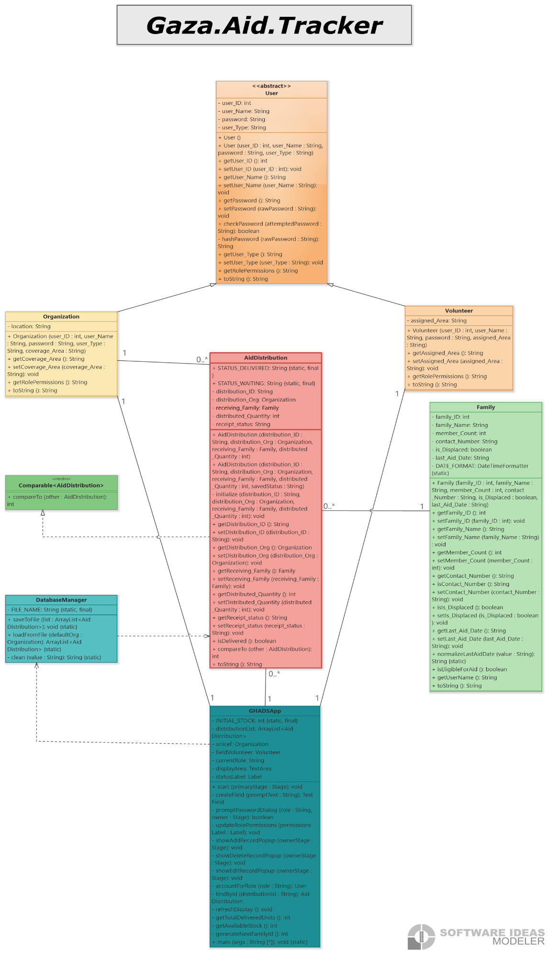
Figure 1 — UML class diagram of the GHADS system
6. Screenshots

Figure 2 — Main Dashboard
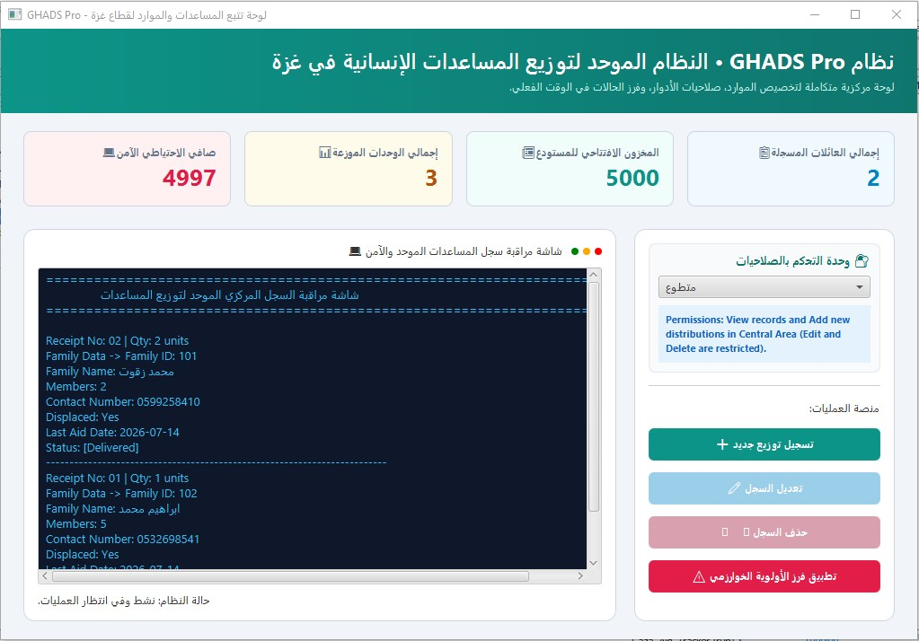
The main dashboard displays the system statistics, available stock, distributed items, remaining inventory, user-role selection, and the distribution records. It is the main interface used to perform all system operations.

Figure 3 — Organization Login
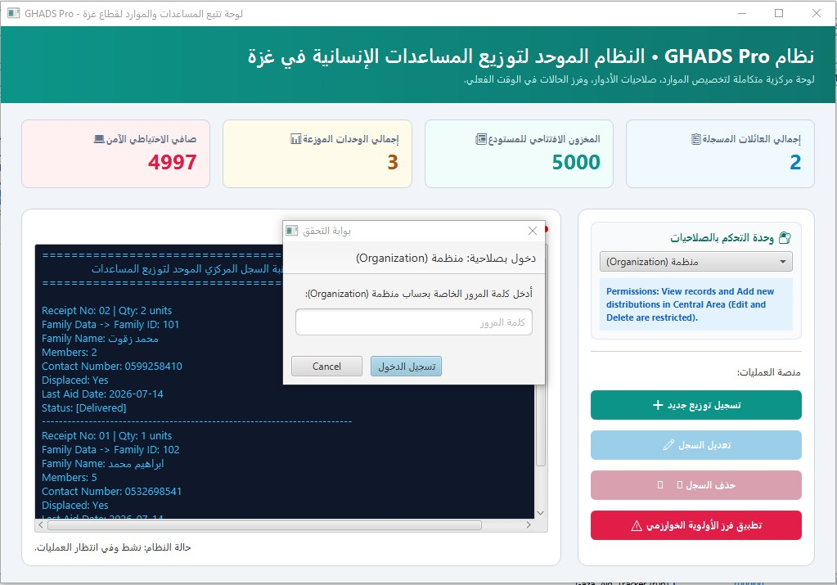
The login window is displayed before accessing organization-level operations. The user must enter the correct password to continue.

Figure 4 — Successful Login
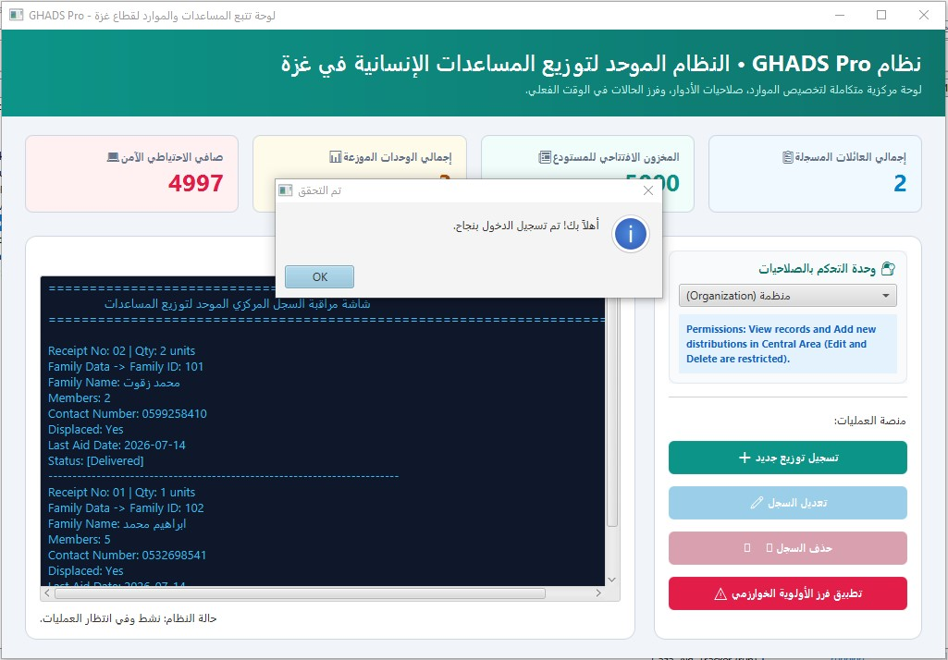
This message confirms that the entered password is correct and the organization role has been activated successfully.
Figure 5 — Add Distribution
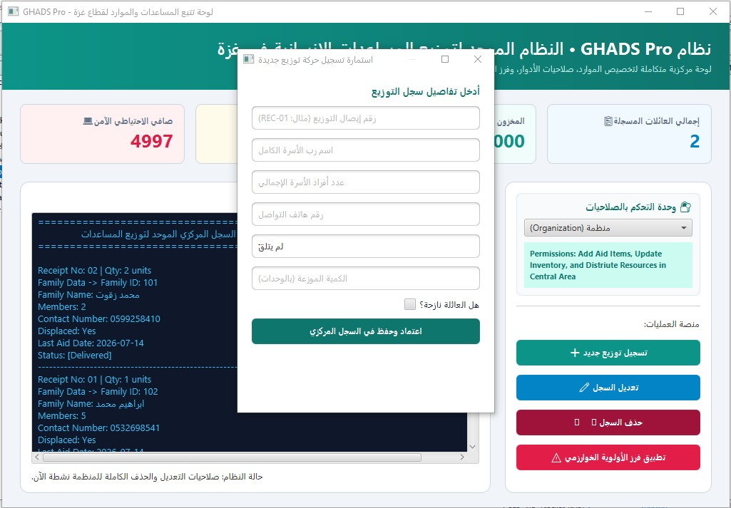
This window allows the user to add a new aid-distribution record by entering the required family and distribution information.

Figure 6 — Edit Distribution
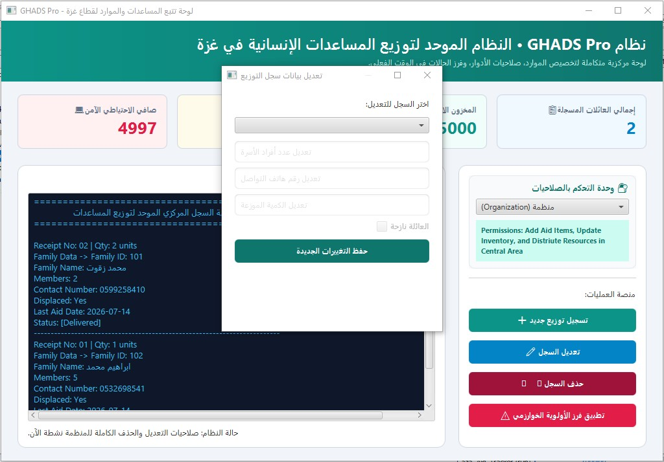
This window is used to update an existing distribution record after selecting it from the system.

Figure 7 — Delete Distribution
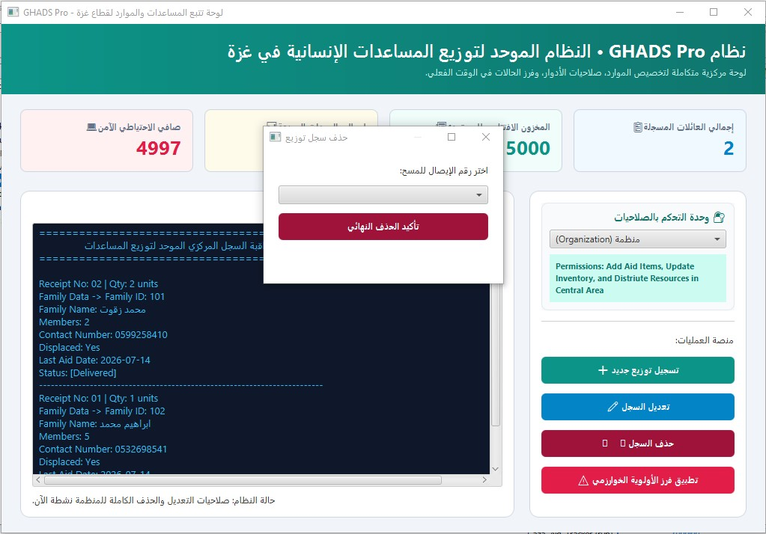
This window allows the organization to delete a selected distribution record after confirmation.

Figure 8 — Project Structure & Inheritance in NetBeans
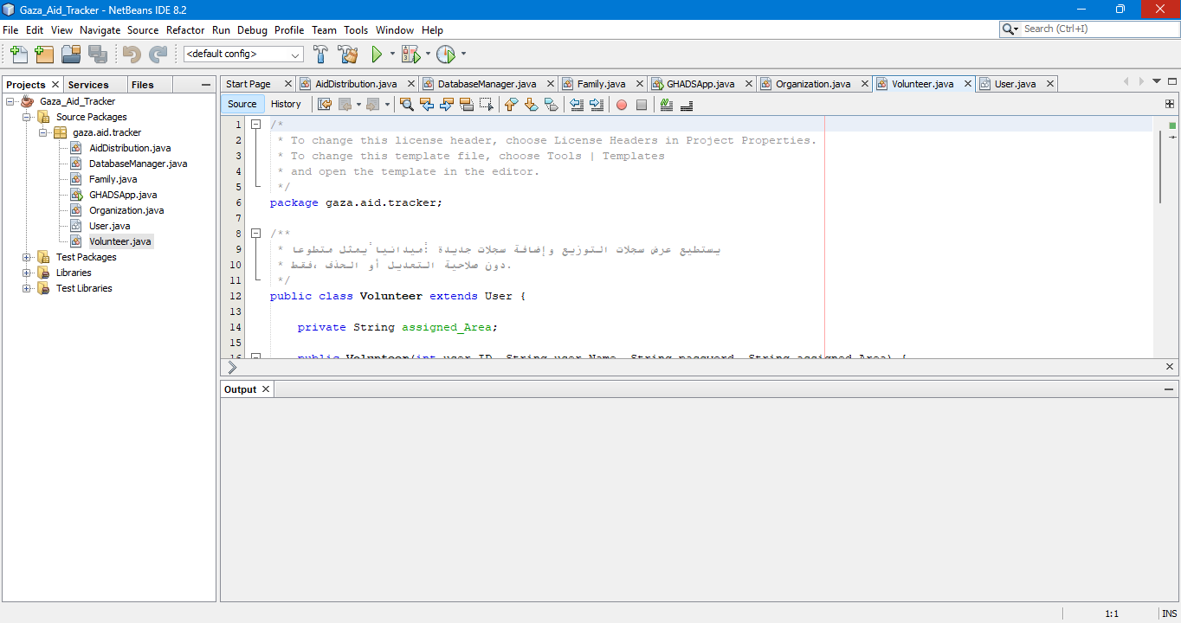
The NetBeans project explorer shows all source files, alongside Volunteer.java, which declares public class Volunteer extends User — a direct, on-screen example of the inheritance relationship described in Section 3.2 (Organization follows the identical pattern).

7. Challenges
During the development of this project, we faced the following challenges:
- Designing the class relationships and applying the OOP concepts correctly, especially deciding which behaviour belonged in User versus its subclasses.
- Connecting the JavaFX interface with the backend classes, and keeping the displayed statistics in sync with every add, edit, and delete operation.
- Implementing file handling to save and load distribution records correctly, including safely skipping corrupted or incomplete rows instead of crashing on startup.
- Making sure a family is never unfairly blocked from receiving aid because of a badly formatted or missing last-aid-date value, while still enforcing the 30-day eligibility rule correctly for valid dates.
- Building a fully right-to-left Arabic interface with JavaFX, which required explicitly setting the node orientation on multiple controls and dialogs individually.
- Completing the project within the required deadline while working under difficult circumstances, including delays in charging our devices and unstable internet connectivity, which sometimes slowed down communication and testing.
Despite these challenges, we successfully completed the project and met all the project requirements.

8. Video Presentation Link
Video: https://youtu.be/mCyRo4I89ss

10. AI Usage Declaration
The core project idea, class architecture, business logic, and the complete implementation were developed entirely by the project team. We used AI tools (in a limited capacity as a learning and guidance assistant during the JavaFX GUI design phase, specifically by describing the required functional mechanisms for the interface and receiving general design guidance. The design of core classes, business logic, and the integration of all system components were achieved and thoroughly understood by the team members, who reviewed, tested, and adapted any AI-related design suggestions before including them in the final project.

Developer View
Designed by: Noura Mahmoud Srour
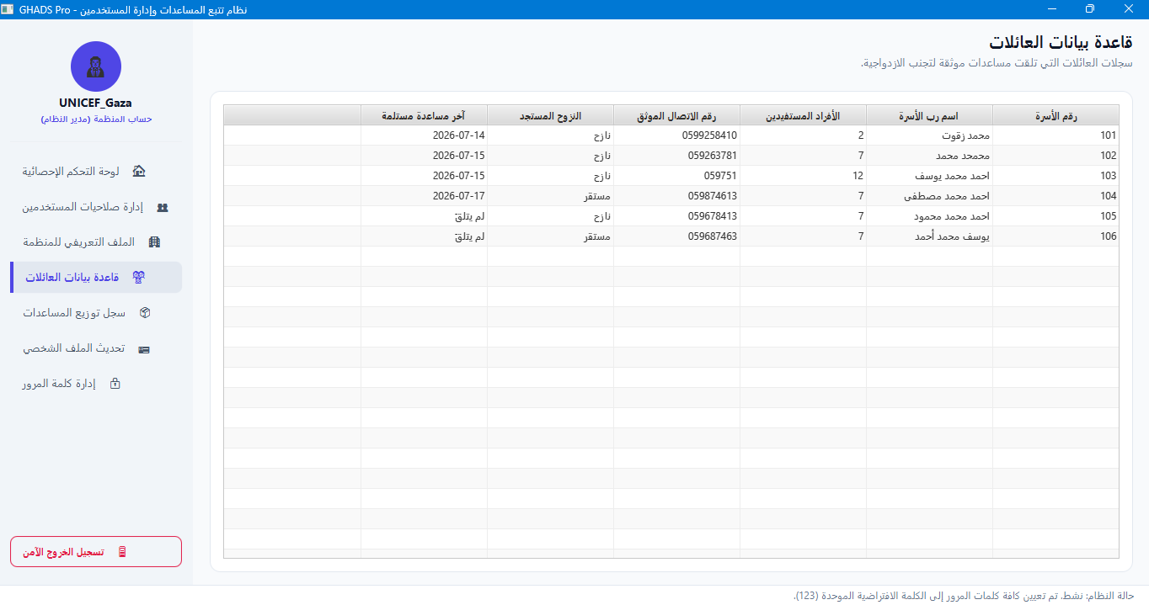
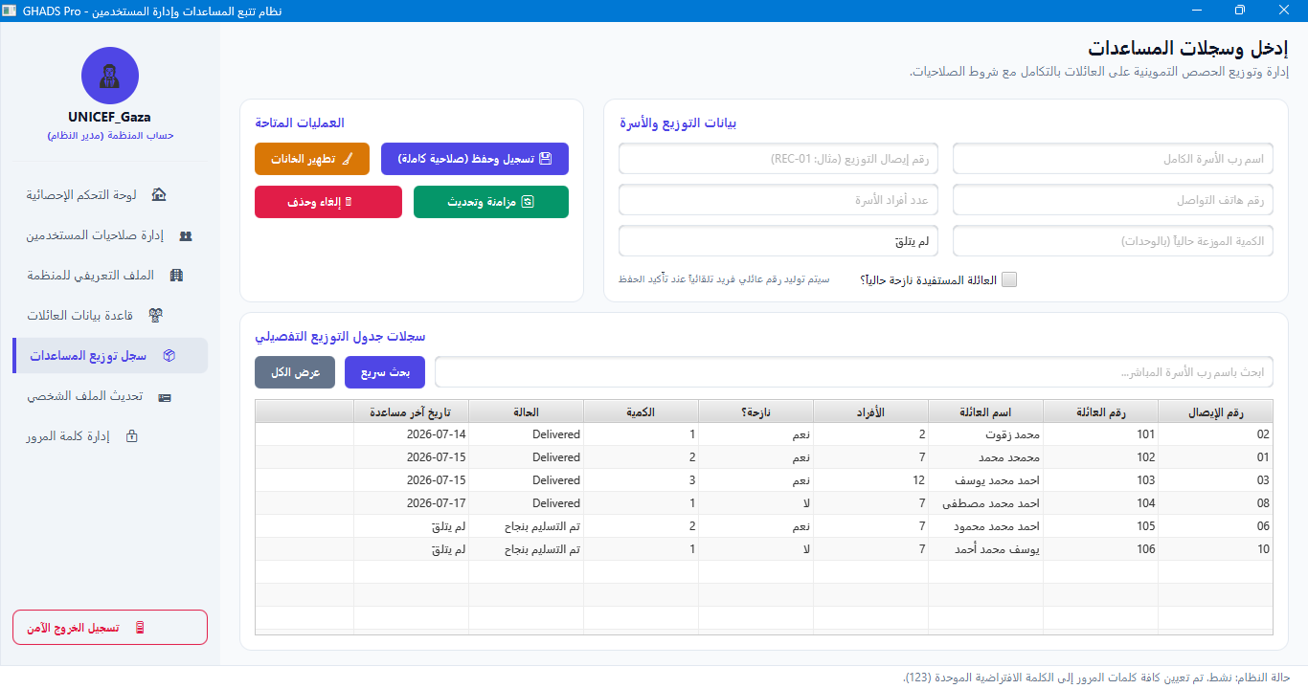
GHADSAppDeveloper.java

